**turmoil, envisaged, cashing, bowing, curbing, dabble, embarked, head, scraping, turn, whingeing,**

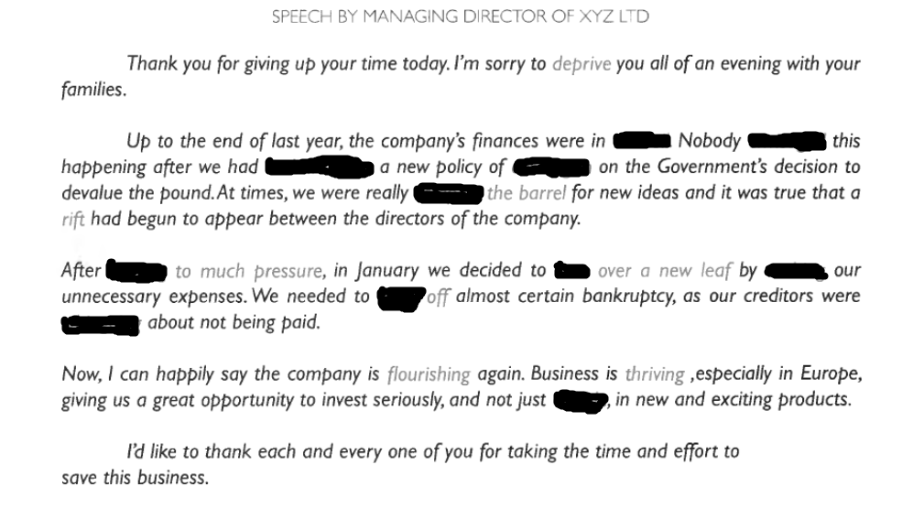

**drawn-out , nip, gist, boiled, shrug, foregone, stretch, top, wimp, sulk, plate,**

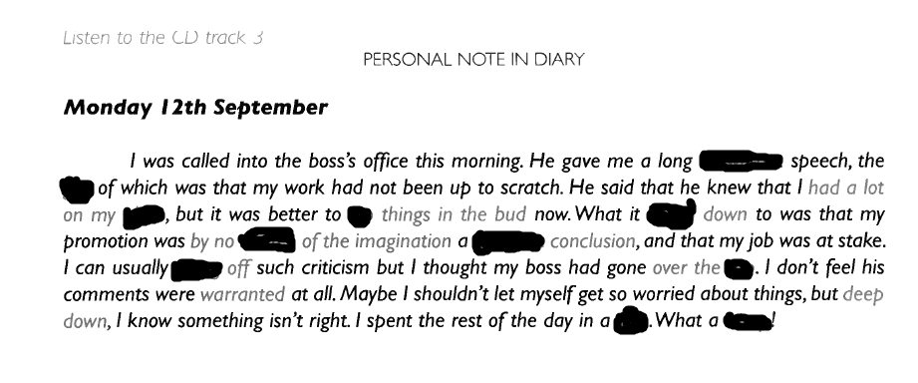

**laid on , outnumbered, profile, wrote, bandwagon, weigh, stumbling,**

